Working with Git Flow in SourceTree

# Starting Off

## Initialize the Repository with Git Flow

1. In SourceTree, click on the button for Git Flow at the top. This will bring up a window such as the one shown below. We’ll be using the defaults so just click OK.  
   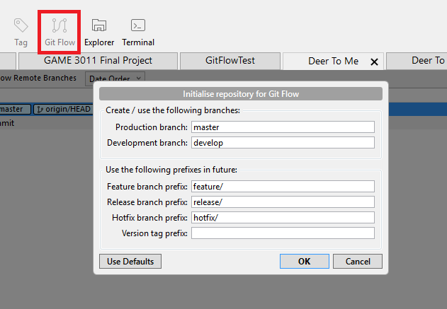
2. Now, there will be two branches on the panel on the left: master and develop. We will always be branching off of develop to start a new feature, and when that feature is finished, merging it back to the develop branch.

## Starting a New Feature

1. First ensure that you have the latest develop branch:
   1. While on the develop branch, click on Fetch to see if anyone has since updated it.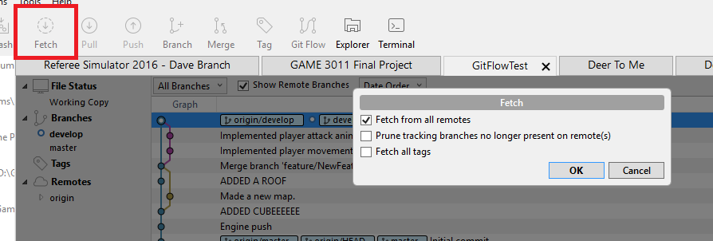
   2. If there has been a change, then a number will appear above Pull indicating how many pushes have been made to it. Click on Pull to retrieve these changes and update your develop branch.
2. Click on Git Flow. This time a different menu will appear. Click on Start New Feature.  
   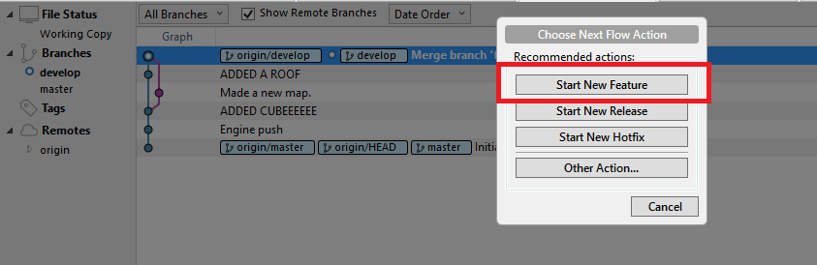
3. Give a name to this new branch that’ll be dedicated to working on this new feature:  
   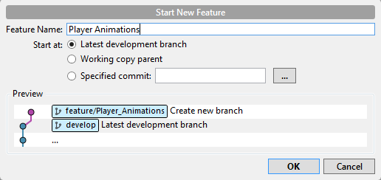  
     
   Once you hit OK, this will automatically create the new branch and place you in it. Now you can start developing this feature.
4. Committing is the same process as usual:
   1. Hit Commit at the top to starting the committing process.
   2. Under ‘Unstaged files’ will be a list of files that SourceTree has recognized a change in or new files it hasn’t seen before.
   3. For any files that you have intentionally edited and wish to commit, move them to the ‘Staged files’ section by clicking on their respective checkboxes.  
      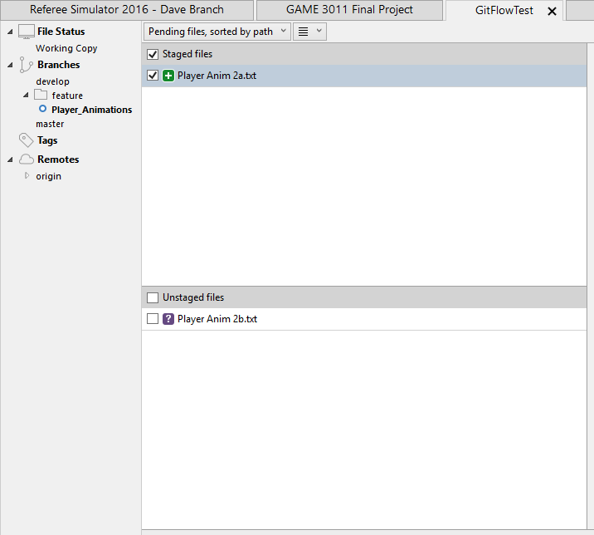
   4. For any files that you have unintentionally edited or simply don’t want to push the change for, right click on them and select Discard (if you’re on Windows) or Reset (if you’re on Mac).
   5. Once all the files under ‘Unstaged files’ have been added or discarded, write a commit message at the bottom and hit Commit.
5. Once you’re finished working on a feature, you’ll want to merge these changes back to the develop branch so that the feature is available to the rest of the team.
   1. Again click on Git Flow at the top. The menu will be different again and will give you the option Finish Feature.  
      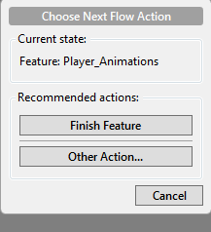
   2. Once you click on Finish Feature, a menu will appear giving you different options. We just want to use the default options here so just click on OK to merge.  
      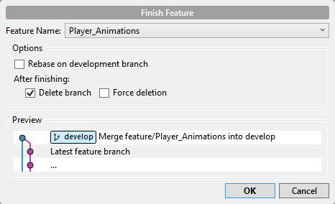
   3. The last step is to push this merge so that the change is reflected over the network. Click on Push.  
      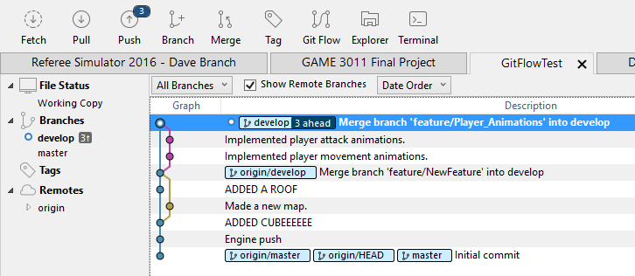
   4. Ensure that you’re only pushing to the develop branch and finally hit OK.  
      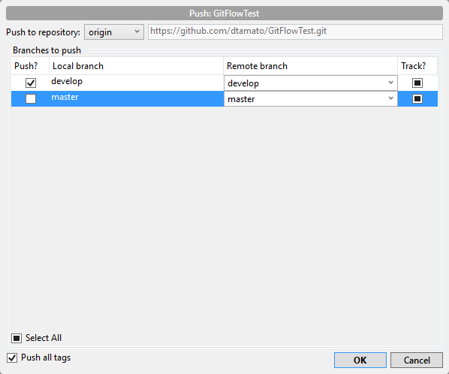
   5. Now in the graph you can see the changes you made being merged to the develop branch. Once you’re ready to start working on a new feature, click on Git Flow and repeat the whole process again.  
      